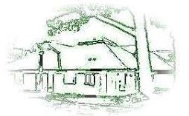
YELVERTON SURGERY

Spring / Summer Newsletter 2026

REASONABLE ADJUSTMENTS

Making Healthcare Accessible for Everyone
Yelverton Surgery is committed to identifying patients who may require reasonable adjustments.

What are Reasonable Adjustments?
They are legal requirements to ensure health services are accessible to disabled people.
Examples include:
- Improved physical access to the Practice
- Easy-read or plain English appointment letters
- Longer appointments if needed
- A quiet waiting space
If you or someone you support has a disability or long-term health condition that makes appointments difficult:
Please speak to a doctor, nurse or member of our team.
We can also add a note to your medical record so adjustments are recognised wherever you receive care.

HAY FEVER SEASON HAS BEGUN!
Hay fever is a common allergy causing sneezing, coughing and itchy eyes.
It cannot be cured, but symptoms can be managed.

▌SYMPTOMS
- Sneezing and coughing
- Runny or blocked nose
- Itchy, red or watery eyes
- Itchy throat, mouth, nose and ears
- Loss of smell
- Facial pain (forehead and sides of head)
- Headache
- Fatigue

WHAT YOU CAN DO

✅ DO
- Apply petroleum jelly around nostrils
- Wear wraparound sunglasses or a wide-brimmed hat
- Shower and change clothes after being outside
- Keep windows and doors closed
- Vacuum regularly & dust with a damp cloth
- Use pollen/HEPA filters where possible

❌ DON’T
- Cut or walk on grass
- Spend long periods outdoors
- Keep fresh flowers indoors
- Smoke or be around smoke
- Dry clothes outside
- Let pets carry pollen indoors

IMPORTANT: HAY FEVER MEDICATIONS
Following national guidance from NHS England, antihistamines and nasal sprays are no longer routinely prescribed for hay fever.
These medications should now be purchased over the counter from your local pharmacy.
If you contact the practice regarding hay fever symptoms, you will be directed to a pharmacist for advice.
We appreciate your understanding.

PRACTICE NOTICE
Yelverton Surgery will be closed:
Thursday 7th May – from 1:00pm
(Reopening Friday 8th May at 7:30am)
This closure allows staff to complete mandatory training.

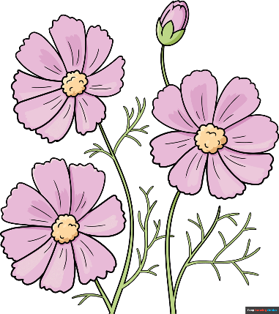

We wish all our patients a wonderful Spring and Summer!

SPRING / SUMMER VACCINATIONS

RSV Vaccination Programme

Invitations will soon be sent for RSV vaccinations.

Who is eligible?
- Adults turning 75
- Adults aged 75–79

What is RSV?

Respiratory Syncytial Virus (RSV) is a lung and airway infection that can cause:
- Cough
- Sore throat
- Sneezing
- Runny or blocked nose
- Wheezing or shortness of breath
While often mild, RSV can lead to pneumonia and serious complications, especially in:
- Those with heart or lung disease
- People with weakened immune systems
There is no specific treatment, but vaccination helps reduce severe illness.

COVID-19 Spring 2026 Boosters
Spring boosters are recommended for:
- Adults aged 75+
- Immunocompromised individuals
- Residents of long-term care facilities
- Pregnant or lactating individuals
- Other high-risk groups (based on individual assessment)
Invitations will be sent shortly.

